Network Intrusion Detection using Machine Learning
In this task, a machine learning-based network intrusion detection system was implemented to identify whether network traffic is normal or malicious. Intrusion detection is an important part of cybersecurity as it helps protect systems from unauthorized access, attacks, and data breaches.
A Gradient Boosting Classifier was used as the model for this implementation. A sample dataset was created with features such as packet count, connection duration, number of failed login attempts, bytes transferred, and use of unusual ports. These features help in identifying suspicious network behavior. The dataset was divided into training and testing sets using the train-test split method.
The model was trained using the training dataset and then evaluated using the testing dataset. Performance was measured using accuracy, precision, recall, and F1-score. The results obtained were:
Accuracy: 1.0
Precision: 1.0
Recall: 1.0
F1 Score: 1.0
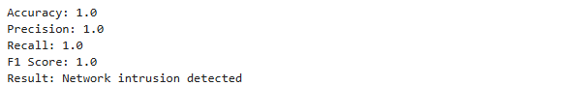
These results indicate that the model correctly classified all test samples. The system was also tested with new network traffic data, and it successfully identified the traffic as an intrusion. This shows that the model is able to learn patterns and detect abnormal behavior in the network.
However, the dataset used in this experiment is small and simplified, which leads to perfect accuracy. In real-world scenarios, network traffic is more complex and includes various types of attacks. Therefore, larger datasets and continuous updates are required to improve detection performance.
In conclusion, the implemented system demonstrates how machine learning can be used effectively for intrusion detection. It provides a simple but powerful approach to identify malicious activities in networks and enhance cybersecurity systems.

